FOI 9135
We would like to understand the volume of implanted ports (as defined below) used within NHS organisations throughout the UK and would be most grateful if you could kindly provide the below information:
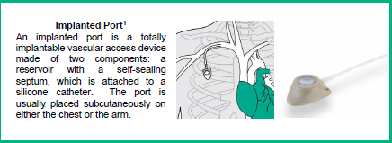
Information requested in respect of Implantable Ports

Question 1 Has your organisation purchased implantable ports in the last 3 years?
Please mark the appropriate with an ‘x’.
Yes | x
No

Question 2 If yes, to question 1, please can you kindly provide a purchasing export report detailing the following relevant to implantable ports for the time periods stated and name the files according to the financial year, including all supply routes. Please feel free to use the attached excel file.
- Manufacturer – Vygon & Kimal
- Brand – Vygon: Polysite, Kimal: Smart Port
- Product Code – Vygon: 2016ISP, Kimal: FSQ1934
- Description – Vygon: POLYSITE ADULT MICRO-PORT POLYURETHANE CATHETER (CN:7005466), Kimal: PORT TITANIUM/CARBOTHANE 6.6FG X 55CM DETACHED CATHETER
- Volume (in pieces) – 10 each
- Supply route for example, Direct, NHS Supply Chain etc – Vygon – direct, Kimal - SSCL
Time Periods
▪ 1st April 2022 – 31st March 2023
▪ 1st April 2023 – 31st March 2024
▪ 1st April 2024 – 31st March 2025
See attached
1 Lister, S et al, Royal Marsden Manual of Clinical Nursing Procedures, 2020, Chapter 17, Vascular Access Devices: Insertion and Management, page 1102

Question 3 If yes, to question 1, please mark with an ‘x’ which clinicians/clinical areas implant ports:
(please select all that are relevant)
Surgeons | x
Anaesthetists
Interventional Radiology
Vascular access Nurses
Other (please state)

Other: ---------------------------------------------------------------

